The Raving Reviewer Challenge
To encourage children to read daily, we are setting our own reading challenge at MMPS - The Raving Reviewer Challenge!
Over the summer, children in KS1 need to read 10 or more books and children in KS2 need to read 4 or more books (the number may be considerably more dependent on the length of the books some children will read) of their own choice.
The books could be from the links we have provided such as Oxford Owl, virtual libraries or their own book that they have at home.
When they have finished each book, they must write a book review as evidence of what they have read.
A good book review includes:
- The title and author of the story
- A brief summary of what it is about (don’t give the story away!)
- Rating out of 5 *****
- Reasons why you would recommend the book
There are templates attached for KS1 / KS2 to print and use, or the children can create their own version – an excellent chance to get creative!
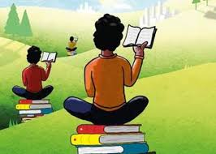
In line with new health and safety rules that we are adopting, children will not be allowed to bring their book reviews into school in September. Instead, they will need to upload their book reviews (a photo or file upload) to their Dojo portfolio by Tuesday 1st September 2020.
There will be a reward for the top 3 readers in each class, which will be judged based on the amount of reviews uploaded to Dojo!

So get cracking those books open, read, review and rave all about it!

